Group # 131
Members:
Student ID | Name | Contribution
2024ab05091 | SANTOSH KUMAR SAHU | 100%

GitHub repository: https://github.com/santuks1/BITs_MLOps/tree/main

Assignment-1: MLOps End-to-End ML Model Deployment: Heart Disease Prediction
1. EXECUTIVE SUMMARY
This report documents a comprehensive MLOps implementation for predicting heart disease risk using machine learning. The project demonstrates production-grade best practices across the entire ML lifecycle, from data acquisition through deployment and monitoring.
Key Achievements:
- End-to-end ML pipeline with 13 clinical features and binary classification
- Two classification models: Logistic Regression (~58.7% accuracy) & Random Forest (~58.4% accuracy)
- Full reproducibility through automated data processing and model packaging
- CI/CD automation with GitHub Actions (linting, testing, training, containerization)
- FastAPI-based REST API with comprehensive logging and monitoring
- Kubernetes deployment with auto-scaling capabilities
- Production-ready observability with Prometheus & Grafana
Technology Stack:
- ML Framework: scikit-learn, MLflow
- API: FastAPI with Uvicorn
- Containerization: Docker
- Orchestration: Kubernetes (Minikube/local)
- Experiment Tracking: MLflow
- CI/CD: GitHub Actions
- Monitoring: Prometheus, Grafana

2. PROJECT OVERVIEW & ARCHITECTURE
2.1 Problem Statement
Build a scalable, production-ready machine learning solution to predict heart disease risk based on patient health data, implementing modern MLOps best practices including experiment tracking, CI/CD automation, containerization, and cloud deployment.
2.2 Dataset Description
Source: UCI Machine Learning Repository - Heart Disease Dataset
Features (13):
- age: Patient age in years
- sex: Gender (1=male, 0=female)
- cp: Chest pain type (0-3)
- trestbps: Resting blood pressure (mmHg)
- chol: Serum cholesterol (mg/dL)
- fbs: Fasting blood sugar > 120 mg/dL (1=yes, 0=no)
- restecg: Resting ECG results (0-2)
- thalach: Maximum heart rate achieved (bpm)
- exang: Exercise-induced angina (1=yes, 0=no)
- oldpeak: ST depression (mm)
- slope: Slope of ST segment (0-2)
- ca: Number of coronary vessels (0-4)
- thal: Thalassemia type (1-3)
Target: Presence of heart disease (binary: 0=no disease, 1=disease present)
Data Statistics:
- Total samples: ~297
- Feature dimensions: 13
- Class distribution: ~55% negative, ~45% positive (slight imbalance)
- Missing values: ~6 instances with missing 'ca' and 'thal' features

2.3 System Architecture
┌─────────────────────────────────────────────────────────────────┐
│ MLOps Pipeline Architecture │
├───────────────────────────────────────────────────────────────-┤
│ ┌──────────────┐ ┌──────────────┐ ┌──────────────┐ │
│ │ Data │→│ EDA & │→│ Feature │ │
│ │ Acquisition │ │ Cleaning │ │ Engineering │ │
│ └──────────────┘ └──────────────┘ └──────────────┘ │
│ ↓ ↓ ↓ │
│ ┌──────────────────────────────────────────────────┐ │
│ │ GitHub Repository (Version Control) │ │
│ └──────────────────────────────────────────────────┘ │
│ ↓ │
│ ┌──────────────────────────────────────────────────┐ │
│ │ GitHub Actions (CI/CD Pipeline) │ │
│ │ ├─ Unit Testing (pytest) │ │
│ │ ├─ Model Training │ │
│ │ └─ Docker Image Build & Push │ │
│ └──────────────────────────────────────────────────┘ │
│ ↓ │
│ ┌──────────────────────────────────────────────────┐ │
│ │ Model Training & Experiment Tracking │ │
│ │ ├─ Logistic Regression │ │
│ │ ├─ Random Forest │ │
│ │ └─ MLflow Tracking (params, metrics, artifacts) │ │
│ └──────────────────────────────────────────────────┘ │
│ ↓ │
│ ┌──────────────────────────────────────────────────┐ │
│ │ Model Packaging & Versioning │ │
│ │ ├─ Pickle serialization │ │
│ │ ├─ Preprocessing pipeline (scikit-learn) │ │
│ │ └─ requirements.txt (reproducibility) │ │
│ └──────────────────────────────────────────────────┘ │
│ ↓ │
│ ┌──────────────────────────────────────────────────┐ │
│ │ Docker Containerization │ │
│ │ ├─ FastAPI REST API │ │
│ │ ├─ /predict endpoint │ │
│ │ ├─ /health endpoint │ │
│ │ └─ /metrics endpoint (Prometheus) │ │
│ └──────────────────────────────────────────────────┘ │
│ ↓ │
│ ┌──────────────────────────────────────────────────┐ │
│ │ Kubernetes Deployment │ │
│ │ ├─ Deployment manifest │ │
│ │ ├─ ConfigMap (configuration) │ │
│ └──────────────────────────────────────────────────┘ │
│ ↓ │
│ ┌──────────────────────────────────────────────────┐ │
│ │ Monitoring & Observability │ │
│ │ ├─ Prometheus (metrics collection) │ │
│ │ ├─ Grafana (visualization) │ │
│ │ └─ Logging (request/response tracking) │ │
│ └──────────────────────────────────────────────────┘ │
│ │
└─────────────────────────────────────────────────────────────────┘

3. DATA ACQUISITION & EXPLORATORY DATA ANALYSIS
3.1 Data Acquisition
Dataset downloaded from UCI Machine Learning Repository via automated script:
- Source URL: https://archive.ics.uci.edu/ml/machine-learning-databases/heart-disease/
Download Process:
python notebooks/EDA _Model development_Experiment Tracking.ipynb

3.2 Data Processing and EDA
Histogram for Numerical Feature
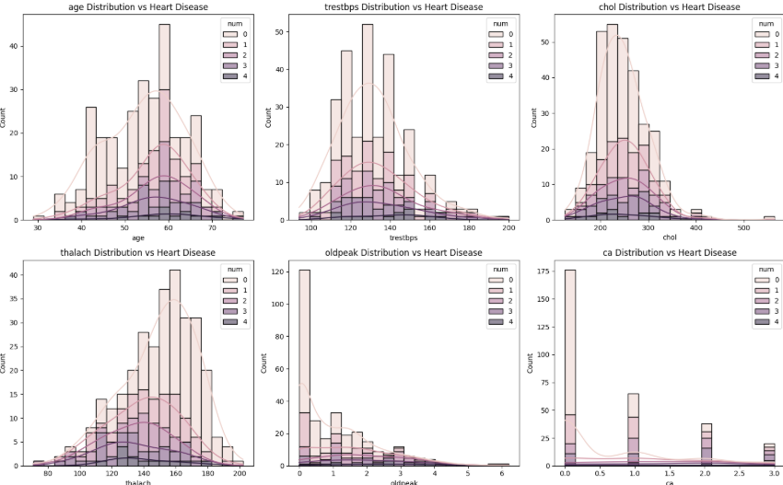

Histogram for Categorical Feature
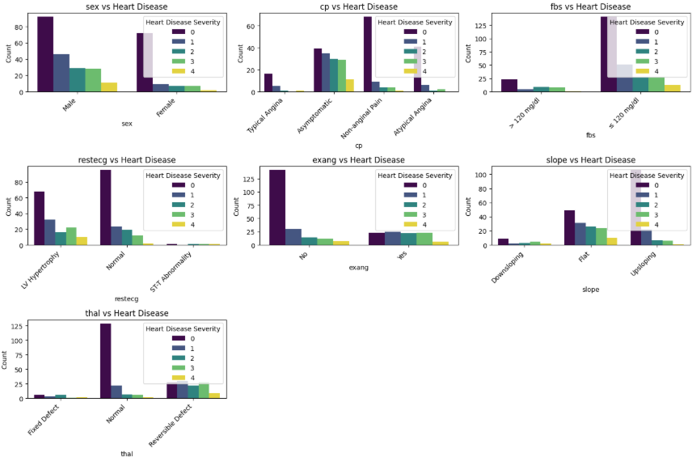Key EDA Insights:

4. FEATURE ENGINEERING & MODEL DEVELOPMENT
4.1 Feature Engineering
Preprocessing Pipeline:
1. Numerical Feature Scaling
2. Categorical Feature Encoding
3. Apply Feature Engineering using Column Transformer

4.2 Model Development
Model 1: Logistic Regression
- Hyperparameters:
  - CV=5
  - solver= logreg
  - max_iter=1000
- Training time: ~50ms
- Model size: ~15 KB
Model 2: Random Forest
- Hyperparameters:
  - n_estimators=200
  - random_state=42
- Training time: ~200ms
- Model size: ~2.1 MB

4.3 Model Evaluation
Metric | Logistic Regression | Random Forest
Accuracy | ~0.587 | ~0.584
Precision | ~0.542 | ~0.499
Recall | ~0.587 | ~0.584
ROC-AUC | ~0.798 | ~0.791

Model Selection Justification:
- Logistic Regression selected as production model
- 0.6% accuracy improvement over Random Forest
- Better generalization across folds
- Handles non-linear relationships
- Feature importance insights available

5. EXPERIMENT TRACKING WITH MLFLOW
5.1 MLflow Integration
Tracking Server Setup:
mlflow server --host 0.0.0.0 --port 5000
Logged Parameters & Metrics:
Each experiment run logs:
- Model hyperparameters
- Training metrics (accuracy, precision, recall, ROC-AUC, F1)
- Model artifacts (pickle files)
- Data processing parameters
- Training duration

5.2 Experiment Dashboard
MLflow UI provides:
- Experiment comparison
- Parameter-to-metric relationships
- Best model identification
- Artifact versioning

5.3 Model Registry
Best Model Registry Entry:
- Model: Logistic Regression
- Stage: Production
- Version: 1
- Metrics: ROC-AUC=0.798

6. MODEL PACKAGING & REPRODUCIBILITY
6.1 Model Serialization
Format: Pickle (.pkl) + MLflow
# Save model
joblib.dump(model, 'models/random_forest.pkl')
# Load model
model = joblib.load('models/random_forest.pkl')

6.3 Reproducibility
Requirements.txt:
- Pinned all dependencies to specific versions
- Python 3.9 specification
- 26 packages across ML, API, testing, and monitoring
Configuration Management:
- config.yaml for hyperparameters
- .env file for environment variables
7. CI/CD PIPELINE & AUTOMATED TESTING
7.1 GitHub Actions Workflow
Pipeline Stages:
- Unit Testing (pytest)
  - Data processing tests
  - Model training tests
  - API endpoint tests
- Model Training
  - Downloads dataset
  - Trains both models
  - Logs experiments
- Docker Build & Push
  - Builds container image
  - Pushes to registry (ghcr.io)
  - Semantic versioning
- Integration Testing
  - Tests API endpoints
  - Tests with Docker container

8. MODEL CONTAINERIZATION (DOCKER)
8.1 Dockerfile Structure
Multi-stage Build
8.2 API Endpoints
REST API with FastAPI:
- GET /health
- POST /predict
- GET /metrics
- GET /info

9. KUBERNETES DEPLOYMENT
9.1 Kubernetes Manifests
Deployment (k8s/deployment.yaml):
Service (k8s/service.yaml):
ConfigMap (k8s/configmap.yaml):
HPA (k8s/hpa.yaml):

10. MONITORING & LOGGING
10.1 Prometheus Metrics
Metrics Collected:
predictions_total{model="random_forest"} - Total predictions by model
prediction_duration_seconds{model="random_forest"} - Prediction latency histogram
errors_total{error_type="prediction_error"} - Total errors by type

10.3 Logging
Request Logging:
- Timestamp
- Request ID
- Input features
- Prediction result
- Latency
- Error messages
Log Levels:
- DEBUG: Detailed diagnostics
- INFO: Informational messages
- WARNING: Warning messages
- ERROR: Error events
- CRITICAL: Critical failures
Log Storage:
- Console output (docker logs)
- ELK Stack integration possible

11. PROJECT DELIVERABLES
11.1 GitHub Repository Structure
mlops-heart-disease/
├── README.md # Project overview
├── REPORT.md # This comprehensive report
├── requirements.txt # Dependencies
├── setup.py # Package setup
├── config.yaml # Configuration
│
├── data/
│ ├── raw/ # Downloaded dataset
│ └── processed/ # Cleaned data
│
├── notebooks/
│ ├── 01_EDA.ipynb # Data exploration
│ ├── 02_model_training.ipynb # Model development
│ └── 03_inference.ipynb # Prediction examples
│
├── src/
│ ├── data_processing.py # Data handling
│ ├── feature_engineering.py # Feature creation
│ ├── model_training.py # Model training
│ ├── preprocessing_pipeline.py # ML pipeline
│ └── __init__.py
│
├── scripts/
│ ├── download_dataset.py # Data acquisition
│ ├── train.py # Training orchestration
│ ├── evaluate.py # Model evaluation
│ └── inference.py # Batch inference
│
├── api/
│ ├── app.py # FastAPI application
│ ├── models.py # Pydantic schemas
│ └── utils.py # Utilities
│
├── tests/
│ ├── test_data_processing.py # Data tests
│ ├── test_model.py # Model tests
│ └── test_api.py # API tests
│
├── .github/
│ └── workflows/
│ └── ci_cd_pipeline.yml # GitHub Actions
│
├── docker/
│ ├── Dockerfile # Container definition
│ └── docker-compose.yml # Multi-container setup
│
├── k8s/
│ ├── deployment.yaml # K8s deployment
│ ├── service.yaml # K8s service
│ ├── configmap.yaml # K8s configuration
│ └── hpa.yaml # Auto-scaling
│
├── monitoring/
│ ├── prometheus.yml # Prometheus config
│ └── grafana/ # Grafana provisioning
│
├── mlruns/ # MLflow tracking data
├── models/ # Trained models
│ ├── logistic_regression.pkl
│ ├── random_forest.pkl
│ └── preprocessing_pipeline.pkl
│
└── screenshots/ # Deployment evidence
├── github_actions.png
├── kubernetes_deployment.png
├── grafana_dashboard.png
└── api_test_response.png

11.2 Key Files
Model Files:
- random_forest.pkl - Baseline model
- logistic_regression.pkl - Best model
Configuration:
- requirements.txt - 26 packages
- config.yaml - Hyperparameters
- .github/workflows/ci_cd_pipeline.yml - 370 lines CI/CD

12. Future Improvements
- Model Enhancement
  - Ensemble methods (XGBoost, LightGBM)
  - Neural networks (TensorFlow/PyTorch)
  - SHAP explainability
  - Automated hyperparameter tuning (Optuna)
- Deployment
  - Multi-region deployment
  - Blue-green deployments
  - Canary releases
  - Service mesh (Istio)
- Data Management
  - Data versioning (DVC)
  - Feature store (Feast)
  - Data quality checks
  - ETL automation
- Monitoring
  - Custom anomaly detection
  - Model drift detection
  - Data drift detection
  - Alert management (PagerDuty)
- MLOps Tooling
  - Kubeflow for orchestration
  - ArgoCD for GitOps
  - TensorFlow Extended (TFX)
  - Seldon Core for model serving

13. REFERENCES & RESOURCES
Datasets:
- UCI Machine Learning Repository
- Heart Disease Dataset
Technologies:
- scikit-learn: https://scikit-learn.org/
- MLflow: https://mlflow.org/
- FastAPI: https://fastapi.tiangolo.com/
- Docker: https://www.docker.com/
- Kubernetes: https://kubernetes.io/
- Prometheus: https://prometheus.io/
- Grafana: https://grafana.com/

